**Beginner Property Secrets**

Unlock & learn rock-solid, time-tested property investing systems

Come to our Peterborough offices, spend one full day with us and 18 other beginner Property Investors for an intimate and personal Q&A. Your personal questions answered by the UK’s leading property trainers and investors, live at our training academy (that we bought BMV & NMD – explained on the day): See the UK’s largest property training operation live from the inside.

This gives any new investor the shortest route to property cash flow success.

Learn Buy to Let, Buy to Sell (Flip), JV’s & Low/ None of your money down investing to cash in on the imminent B2L Boom

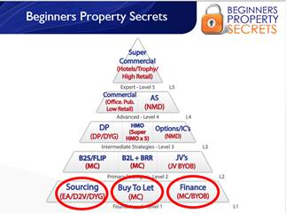

**What you’ll learn on the 1 day Beginner Property Secrets Day:**

Is property for you? Why are YOU here/outcomes?

Is it better than having a job?

How people who have trained with Progressive property changed their level of income and job for the better.

Gain clarity & focus on exactly what to buy, where to buy it and when for maximum income using the Progressive R.E.A.S.O.N & C.A.S.T.L.E.D models

How can you make property work for you?

Your trainer / speaker of the days results – living / social proof with all your questions answered.

Why property is better than having a pension.

How to run a portfolio part time / full time

Learn Buy to Let, Buy to Sell (Flip), JV’s & Low/ None of you money down investing to cash in on the imminent B2L Boom

Look at the journey of any property investor over time so you know what to expect

Sourcing, finance and buy to lets – beginner strategy explained.

Find them, fund them fill them strategy to move quickly with your property portfolio.

Case studies explained on the day.

How property investing, portfolio building & passive income is free.

General overview of the property market

Goldmine cash flowing areas where you live

How to add value to properties

How to find below market value properties

How to work with a JV partner for the future.

Use minimum cash, time & risk for maximum cashflow, portfolio growth & pension provision for the long term

Systemising your business

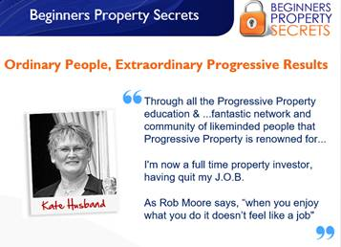

What is the beginner property secrets day? <https://www.youtube.com/watch?v=hHlJniCr0AA>

**Location:**

Progressive property HQ

Unit 9

Forder way, Cygnet Park,

Hampton, Peterborough

Pe7 8gx